1. Download the Java SDK

<https://www.oracle.com/java/technologies/javase/javase-jdk8-downloads.html>

I recommend you download the 64-bit version. Filename: jdk-8u251-windows-x64.exe.

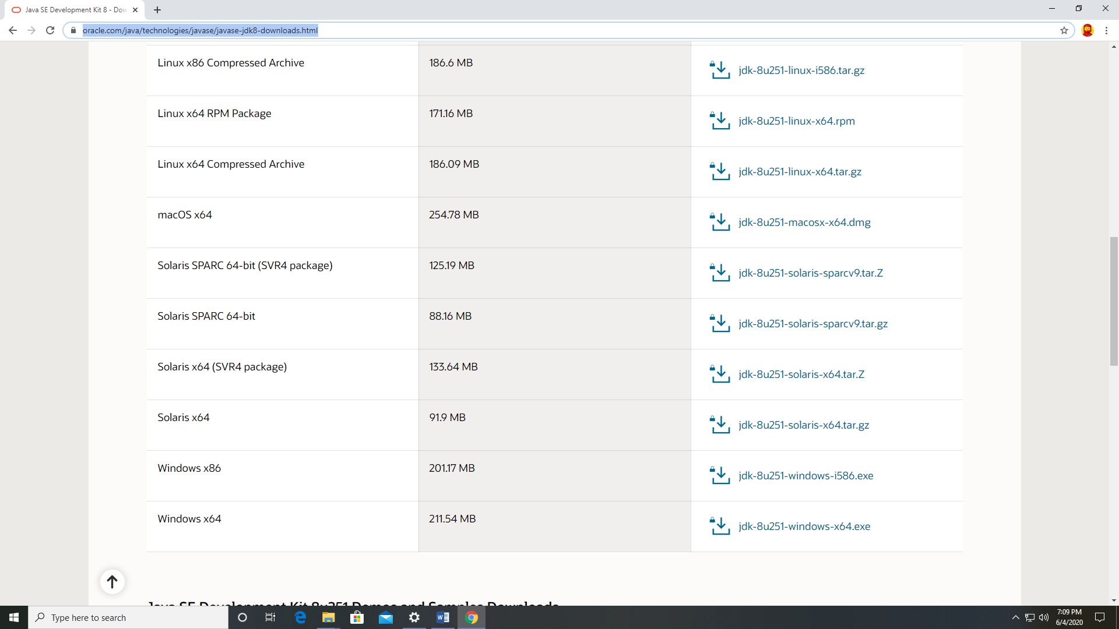

Note: You will need to setup an Oracle Account to download. You should use your school email account to do this.

1. Double click on the file and the installation process should begin. Accept all of the defaults. This will install not only the Java SDK but also the Java Runtime.
2. Next we need to install JCreator (The IDE we use). The free version (4.5 Lite) is no longer available. If you email me [nmessa@sau16.org](mailto:nmessa@sau16.org) I can share the file with you.
3. Double-click on the file to start the installer and use all of the default settings.